With rising inflation, falling interest rates and skyrocketing real estate prices, what will your retirement look like? In 1994 William Bengen, a financial planner, gave a broad answer to this question after conducting a study on portfolio performances from years 1926 to 1976. His answer was simple: every year retirees can spend four percent of the initial value of their investment portfolio adjusted annually for inflation without going broke. In other words, if you start retirement at age 70 with a $1 million investment portfolio, you can spend $40,000 your first year and this same amount every subsequent year adjusted for inflation. For years now critics in the financial industry have taken issue with this rule of thumb for being too broad and antiquated, but today we are going to conduct new analysis of this rule using much newer data ranging from 1914 to 2015.

In our analysis we’ve taken historic S&P500 data and simulated the result of every 30 year retirement starting on January 1st for years 1915 to 1985. This yielded 72 simulations with the first spanning January 1st 1914 to January 1st 1944 and the last spanning January 1st 1985 to January 1st 2015. In each simulation the retiree started with $1 million and spent $40,000 annually adjusted for inflation. In the first year of their simulated retirement $900,000 of the portfolio is invested in the S&P500 and $100,000 is in cash, during down years if the cash depleted too far some of the S&P500 stock was sold to re-adjust the cash balance to be a 1 to 10 ratio to the value of the S&P500 stock. Here are the results of the simulations.

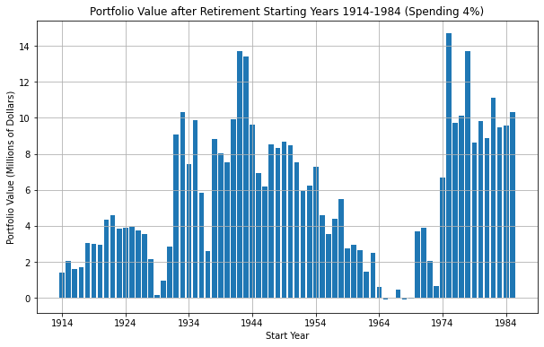

In this bar chart the x-axis location of each bar denotes the year the retiree started their 30 year retirement following the 4% rule guidelines. The height of the bar denotes the value of their portfolio at the end of retirement. It should be noted that the final value does not include the value of all the money the retiree spent during their retirement ($40,000 annually adjusted for inflation). Thus if we look at the bar for year 1975 we can see that it is half way above the $14 million mark, meaning the retiree who retired in 1975 and ended retirement in 2010 got to spend their four percent and still had over $14 million dollars left.

This chart may look promising but out of the 72 simulated retirements 4 of them went broke. Retirees starting in years 1965, 1966, 1968 and 1969 all ran out of money near the end of retirement. Thus using the 4% rule of thumb will yield about a 6% chance of going broke before the end of your 30 year retirement.

There are two primary reasons for such radical differences in portfolio values: volatility of the market and the change in inflation rates over the years. Buying into the market in the late 1920’s would yield disastrous short term and poor long term portfolio performance, since this is the period right before the Great Depression. In the mid 1940’s the inflation rate was much higher than the historic 2% average, during 1947 it was 14%. For a retiree starting in 1940, this means that initial annual draw of $40,000 would climb to over $100,000 by 1970. Inflation has not been a major issue in the last few decades but now it is going to be something to keep your eye on as trillions of dollars have been printed to stimulate the economy after the pandemic, inflation rates are already starting to rise but have yet to get out of control.

Below you will find a histogram with this same data. The x-axis of the bar denotes the value of the portfolio at the end of retirement in millions of dollars. The height of the bar represents the probability of ending up with this portfolio value at the end of retirement. Thus we can see the highest individual probability is a 15% chance of ending retirement with a $2.5 million portfolio. The average portfolio value is $5.5 million dollars.

Most data sets will fit a normal distribution curve or a “Bell Curve” where the highest probabilities are all nearest the center (the average), but this data sets is bimodal meaning it has two peaks outlined by the best fit line drawn over the data. The significance of this is that it shows a higher variance in the data and thus you should be less certain that you’re going to end up with a certain portfolio value following the 4% strategy.

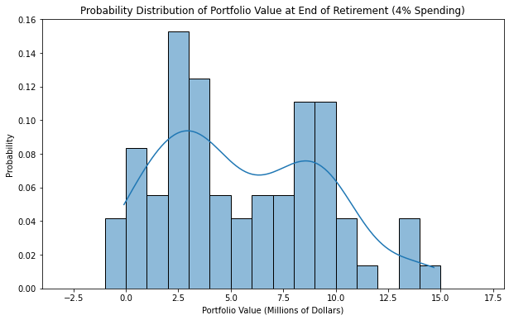

In our next plot you will the fluctuations in portfolio values for three random retirement start years 1930, 1950 and 1980. Right off the bat 1930 was a tough year, the start of the Great Depression. This was one of the worst performing years to start retirement, but the portfolio did consistently stay away from going broke through the whole 30 years. Years 1950 and 1980 show a more common upward growth trend with 1980 showing some volatility in the second half. Fortunately most of the simulations show a growth trend throughout retirement but there are still some years where the 4% rule could be too close for comfort.

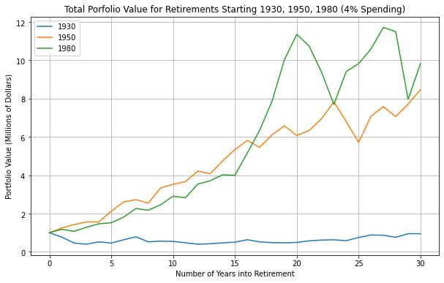

If this analysis of the 4% rule has shown it to be too risky for you then how much can you draw annually without risking, going broke? Below we will conduct the same simulations but using the 3% rule instead. This means all variables are the same in the first analysis only now the retiree will spend $30,000 annually adjusted for inflation. Below you will find the same plot as our first only for the 3% rule. Again, the x-axis is the year started retirement and the height of the bar is the value of the portfolio at the end of retirement. As you can see even the worst performing years 1914 and 1929 still doubled the initial value of the portfolio.

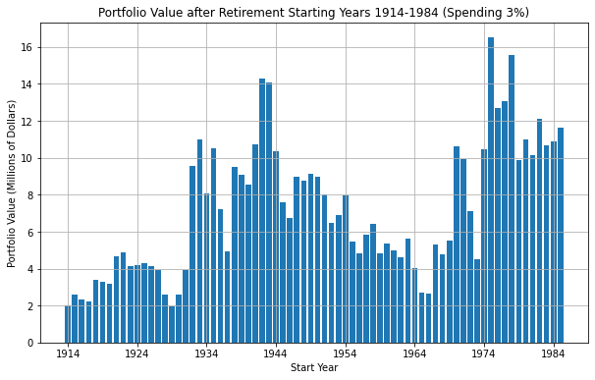

Below you’ll see another histogram of the portfolio simulations for the 3% rule. The average portfolio value is $7 million dollars, and the highest individual probability is a 19% chance of ending retirement with a $4.5 million portfolio. The most important aspect of this plot is that there is a 0% chance of going broke as opposed to a 6% chance using the 4% rule. Although the 3% rule shows a 0% chance of running out of money it is not a guarantee that this can’t happen in the future as market performance and inflation are not deterministic.

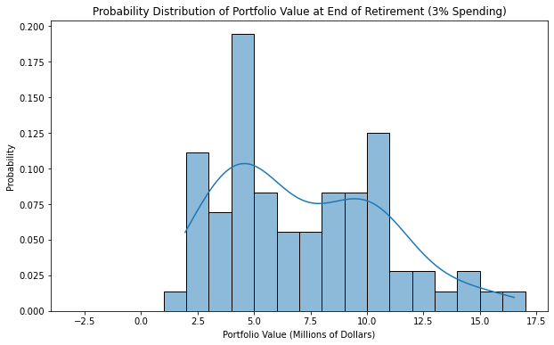

This analysis has used a wider range of data to show that Mr. Bengen’s study of the 4% rule in 1994 still looks to be an alright rule of thumb. There is a very small chance of going broke following the 4% rule and many would argue that in a reality a retiree facing a situation like this would adjust their spending far before they actually run out of money. Some things to note about this analysis are that it does not include taxes or portfolio management fees and many retirement portfolios are diversified between stocks, bonds, mutual funds, commidities, realestate, etc.

The taxes in a real retirement situation will depend on the individual’s situation but for the most part they should be very low as most people can invest in a Roth IRA or 401k which will allow you to pay taxes on contributions in the same year you contribute the money to the IRA or 401k, meaning you will only be taxed on the dividends during retirement.

Investment portfolio managers usually end up taking around 1 or 2% of the porfolio value annually. If you plan on using an active porfolio manager you should be confident they are going to beat the market by the rate the are charging or you should adjust the 4% rule down to maybe 2 or 3%.

This simulation was done using only the S&P500 Index and as stated above most portfolios will have a diversity of holdings that cannot all be represented in a simulation. We do know historically that porfolios with a higher allocation to bonds and fixed income investments will have lower yields in the long term. Allocations into smaller market cap stocks like the Russell 2000 Index have performed better than the S&P500 historically so it’s important to keep in mind how aggresively you plan on allocating your own porfololio when decided how much you’ll be spending each year.

Lastly below is a line plot of the S&P500 Index adjusted for stocks splits and dividends. It is the most common index for doing economic and financial research in recent years and has show tremendous growth in the last century.

